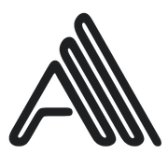
41 Creative Tools to Generate AI Art
Wondering how to make AI art? Scroll down for the best tools to generate AI art.
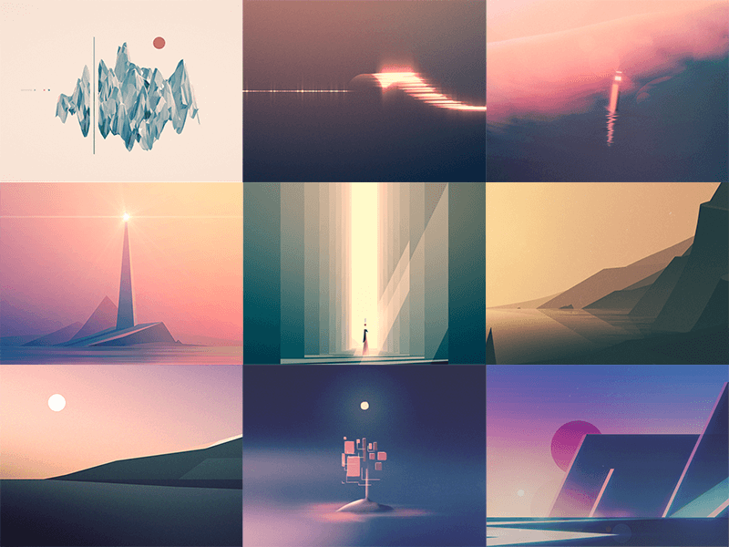
Image © Dave Chenell
Staff Picks to Generate AI Art:
- Runway ML – An easy, code-free tool that makes it simple to experiment with machine learning models in creative ways. Our overall staff pick.
- Nature of Code – This interactive book teaches you how to code generative art; the last chapter is an exceptional introduction to AI art, with real code examples.
- GANBreeder – Breed two images to create novel new ones using GANBreeder. (Note that GANbreeder was renamed ArtBreeder, with several AI models to manipulate photos).
- Magenta – An open source research project exploring the role of machine learning as a tool in the creative process. (Coding skills required).
- Processing – A flexible software sketchbook and language for learning how to code within the context of the visual arts. Includes p5js (Processing for JavaScript) and Processing.py (Processing for Python). [Processing does not use AI, but is a great tool for generative visual art].
- ml5.js – ml5.js aims to make machine learning approachable for a broad audience of artists, creative coders, and students through the web.
- Best laptops for machine learning. We get asked about this so much that we wrote an entire post comparing some of the best laptops for deep learning.
AI Generated Images / Pictures:
- Deep Dream Generator – Stylize your images using enhanced versions of Google Deep Dream with the Deep Dream Generator. Get your Deep Art on.
- DeepArt.io – Upload a photo and apply different art styles with this AI image generator, or turn a picture into an AI portrait of yourself (also check out DreamScope ).
- Visionist: Upload and apply AI Art styles to your photos, including abstract filters, cutout portraits, and more (iOS. Deep Art generator made by 3DTOPO Inc.).
- GoArt – Create AI photo effects that make your photos look like famous portrait paintings with this AI image generator. (Web, Android and iOS. Made by Fotor).
- Deep Angel – Automatically remove objects or people from images with this Deep Art editor. (Web. Made at MIT).
- Google Deep Dream – GitHub repository for implementing Google Deep Dream.
- GANBreeder – Merge images together to create new pictures, make hybrid AI portrals and create wild new forms that have never been seen before. (GANbreeder is now called ArtBreeder).
- Fractal Art Generators - While the fractal art tools on this list don’t use actually AI, a lot of our visitors expressed interest in them because they’re within the realm of computationally generated art.
AI Drawing / AI Painting:
- AutoDraw – Turn your sketch into clip art with this computer generated AI drawing tool.
- AI Painter – Turn your photos into AI paintings or create abstract art with this neural network painting generator.
- Quick, Draw! – A game where a neural net tries to guess what you’re drawing. Draw along with AI and neural networks with this Google draw app.
- Sketch-RNN Demos – Draw together with a neural network.
- Cartoonify – Turn your portrait into a computer generated cartoon drawing.
Datasets:
- Google Dataset Search
- Kaggle Open Datasets
Words and writing:
- GPT-2 – A leading computer generated language model, made by OpenAI.
- Semantris – Word association games powered by semantic search.
- Handwriting with a neural net – Play with a neural net that generates handwriting based on your writing style.
AI Generated Music/Sound:
- Magenta Studio – A collection of music plugins built on Magenta’s open source tools and models.
- AI Duet – Play with a piano that responds to you.
- NSynth Sound Maker – Create your own hybrid sounds and instruments.
- MuseNet – Generate 4-minute musical compositions with 10 instruments, and combine styles from country to Mozart with MuseNet (also available on GitHub).
- Pitch Detection – Use a pre-trained pitch detection model to estimate the pitch of sound file through a computer mic.
AI Generated Movement/Dance:
- AI Sketches With Bill T. Jones – PoseNet experiments made with one of America’s most celebrated artists.
AI Generated Voice:
- Scribbling Speech – Turn real time = speech into animated drawings.
- Thing Translator – Take a picture of something to hear how to say it in a different language.
GANs:
- GAN Zoo – List of named GANs, updated semi-regularly.
- GANS Awesome Applications – Curated list of GANs and demos.
- Teaching Machine to Paint, Write & Play – The definitive book on using GANs for artistic output.
AI Generated Data Visualization:
- Activation Atlases – create an explorable atlas of features a network has learned.
- What neural networks see – visualization of layers in a neural network by Gene Kogan. Also see Feature Visualization by Distill.
- Visualizing high dimensional space – visualize how machine learning works.
- t-SNE – Create compelling two-dimensional “maps” from data with hundreds or even thousands of dimensions.
Learning:
- Teachable machine - Teach a machine using your camera, live in the browser without code.
Typography:
- FontJoy – Generate font combinations with deep learning.
- Font Map – Surface new relationships between fonts with machine learning.
Machine Learning Libraries:
- TensorFlow.js – a library for developing and training ML models in JavaScript.
- scikit-learn – One of the most popular tools for data mining and analysis. Built on NumPy, SciPy, and matplotlib Open source, commercially usable (BSD license).
Closing Thoughts:
If you're interested in using AI in your creative practice, the apps, software and tools above are a great place to start. Even if you have no machine learning experience, you can start with some of the simpler tools and expand from there.
Use AI photo editing tools like Deep Art, an AI art generator like Deep Dream Generator, an AI image generator like Artbreeder (a.k.a. GANBreeder), an AI painting generator like AI Painter, a AI cartoon maker like Cartoonify, or draw with a neural network using Quick Draw.
As tools to make AI art become more mainstream, AI artworks will increasingly embed themselves in our culture. We’re already seeing it in pop album covers, gracing traditional art gallery walls, within digital and pixel art, and expanding our notion of computer generated art.
By mastering the tools to create AI generated art, and creating works while this field is in its infancy, you can help push the boundaries of human creativity forward.
How will your neural network and AI experiments transform our creative potential? Join our exploration of machine learning art, and show us by leading the way!

